**2020-2021 First Grade School Supplies**

For Williams Magnet Elementary School

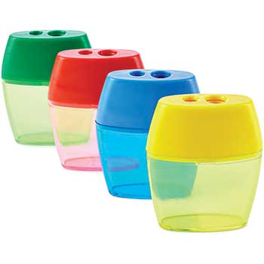**Write your child's name on every school supply except individual pencils.**Please buy exactly what is listed below:

* 1 pencil sharpener with shaving receptacle
* regular size school box
* over the ear headphones
* 1 pair of scissors
* 2 composition notebooks (In school only)
* Dry erase board (approximately the size of sheet of paper ~9” x 12”)*
* Plain paper (at least 120 sheets for first 9 weeks)*
* Items for a counting collection (~100 items – could be coins, paper clips, rubber bands, beads, buttons, cotton puffs, puzzle pieces, chenille stems – anything that doesn’t roll will work)*
* Either a 3 ring-binder (including a hole-punch) and ~5 dividers OR 5 pocket folders (different colors preferred)*
* Girls Purchase: baby wipes (In school only)
* Boys Purchase: Clorox wipes (In school only)
* Purchase for Art: box of washable markers and baby wipes
* Not required but appreciated: gallon size bags

These supplies will need to be bought at the beginning of each new nine weeks:

* 12 Ticonderoga **pre-sharpened** pencils
* 1 large pink eraser
* 1 black dry erase marker
* 2 large glue sticks
* 1 box of 24 count regular crayons
* 1 box of Kleenex

*For virtual students ONLY.

**We look forward to a great first grade year together!**